***Review Analyzer***

*A Rapid Text Summarization and Categorization Tool*

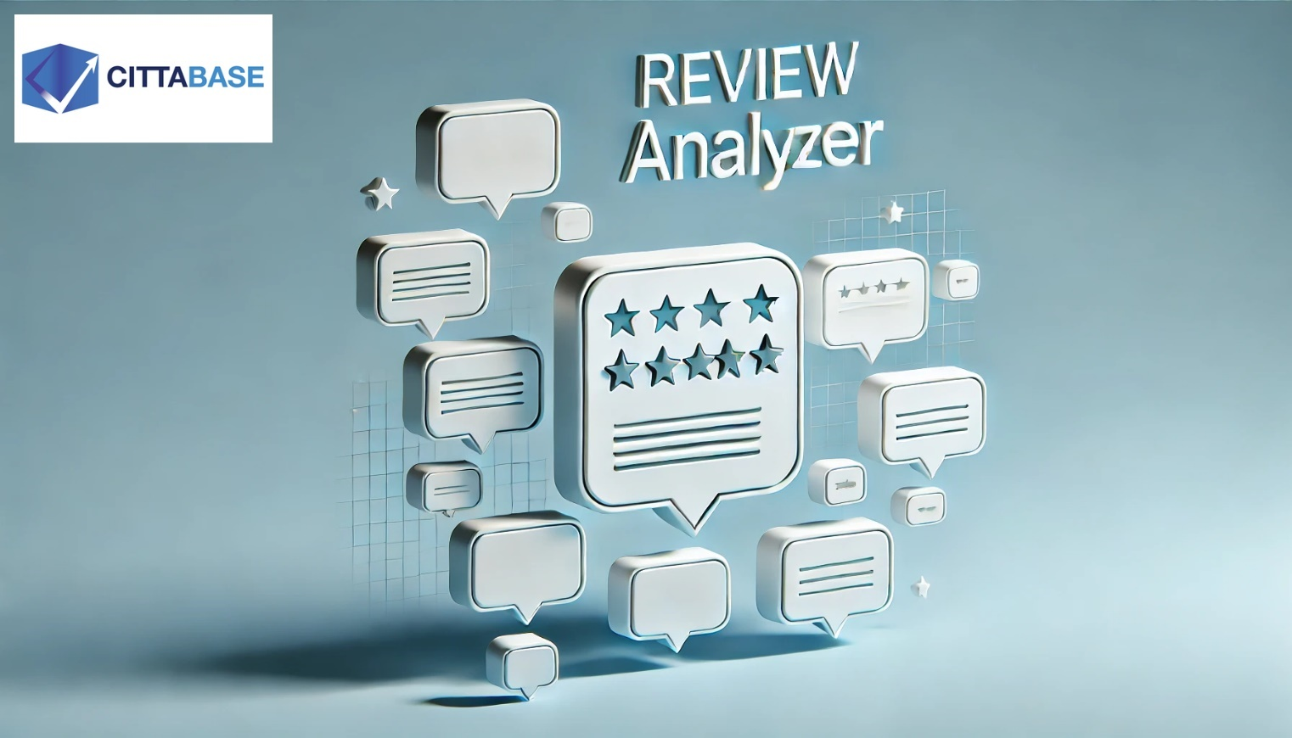

**Table of Contents**

|  |  |
| --- | --- |
| **Section** | **Title** |
| Introduction | Review Analyzer – features |
| 1 | Source from Table |
| 1.1 | Review Categorization |
| 1.2 | Review Summarization |
| 1.3 | Sentiment Prediction |
| 2 | Free Text |
| 2.1 | Review Categorization |
| 2.2 | Review Summarization |
| 2.3 | Sentiment Prediction |
|  |  |
|  |  |
|  |  |

***Review Analyzer*** is a powerful Snowflake Native App designed to streamline the analysis of customer reviews. Whether you need to categorize feedback, generate concise summaries, or predict sentiment, this app provides an intuitive and efficient solution. Users can input review data either through a structured table format—selecting the relevant columns via dropdowns—or by directly typing text into the app. With its seamless integration into Snowflake, **Review Analyzer** leverages advanced analytics to deliver meaningful insights, helping businesses understand customer sentiments and enhance decision-making with ease.

* **Sourced from Table:**

The **"Sourced from Table"** option allows users to input review data from an existing table within Snowflake. Users can select the table and the specific column containing reviews through dropdowns, enabling seamless processing. This method supports analyzing batch data with ease. It also stores the analyzed results, making it ideal for batch processing and long-term insights.

* **Free Text:**

The "Free Text" option allows users to manually enter their review or feedback as text input. The app then processes the input through summarization, categorization, or sentiment prediction, providing instant insights. Since this method analyzes a single review at a time, it is ideal for quick, real-time assessments but does not store the results for future reference.

* A sample dataset for reviews and categories are provided in the following github: link. Execute the setup.sql to get started

➢ If Cortex LLM functions are not enabled, you could consider enabling cross-region inference by referring to the link below: (<https://docs.snowflake.com/en/user-guide/snowflake-cortex/cross-region-inference>). This enables inference requests to be processed from a different region where LLMs are available. Please note that you will be charged credits for the use of LLM as described in detail in the above link. Please review the same. Credits are considered consumed in the requesting region.

➢ This application leverages LLM models, which may exhibit biases and potential inaccuracies based on the data they were trained on. While every effort is made to provide accurate and unbiased insights, the generated descriptions and summaries should be reviewed and validated.

Note: *Review Analyzer utilizes the Mistral-7B LLM within Snowflake and will consume Snowflake credits. Please refer to the official Snowflake Credit Consumption Table (https://www.snowflake.com/legal-files/CreditConsumptionTable.pdf) for detailed credit consumption.*

1. **Sourced from Table**

Select Table dropdown shows the list of tables present in the schema.

Select Column dropdown allows to choose the column which contains the reviews

A preview of the selected columns is visualized in a table format

Select a use case from the dropdown menu

**1.1) Review Categorization:**

When the Review Categorization option is selected, the app gives a prompt to the user to choose the source of categories.

***Note: A table with list of categories must be uploaded to the schema prior use***

If the Categories from Table option is selected, the list of tables from the Review_Analyzer_DB DATABASE will be displayed, as a dropdown. The user can pick the desired category table.  
  
Upon selecting the appropriate category table and clicking Submit, the app leverages large language models and contextually applies categories to the reviews, streamlining analysis and enhancing insights.

It also provides a bar chart to view how the predicted categories are distributed

When the **“Generate categories using the context”** option is selected, the app leverages advanced LLM models to analyze the data and intelligently generate a category based on a tailored prompt, ensuring accurate and context-aware classification.

After categorizing the data, users have the option to store it in the database. To proceed, a unique name must be provided for the stored data. If the chosen name already exists, the system will prompt the user to enter a different name.

This option is found after the Review Summarization and Sentiment Prediction as well.

When given the same name or an already present table name, the app returns the below warning.

**1.2) Review Summarization:**

Upon selecting the Review Summarization option is, the app condenses the input review or feedback into a concise and crisp summary, delivering key insights instantly.

**1.3) Sentiment Prediction**

When the Sentiment Prediction option is selected, the app analyses the input review or feedback and accurately determines its sentiment, providing instant insights into customer emotions.

The app also visualizes the distribution of predicted sentiments with a pie chart, offering a clear and intuitive overview of the predictions.

1. **Free Text**  
     
   With this option, you can enter review or feedback as text input, which the app processes as data. Simply select a function from the dropdown menu, and the app will execute the chosen analysis seamlessly. This option can be used when the user wants to analyze a free flow text review, rather than a set of reviews.  
     
   A screenshot of a computer

   AI-generated content may be incorrect.

**2.1) Review Categorization:**

**2.2) Review Summarization:**

**2.3) Sentiment Prediction:**

Unlike the **"*Sourced from Table*"** option, this method does not support data storage, as it generates a single output in real time.